SMART PHONE APP BASED DEVICE CONTROL SYTSEM
Abstract

This paper presents implementation of cost effective Home Automation System with and remote control. This framework is intended to help and give help to satisfy the needs of the elderly and the handicapped at houses. Additionally, the idea of home automation system will improve the normal living status at houses. The fundamental control system uses a wireless Bluetooth device gives a wireless access to smart phones. The system design does not remove the existing electrical switches and gives a safer control over the switches with low voltage usage technique. The switches status is synchronized every where each person interface demonstrates the current existing switch status. This system is designed to control electrical devices throughout the house with ease of installing it, ease of use and cost effective design and implement.
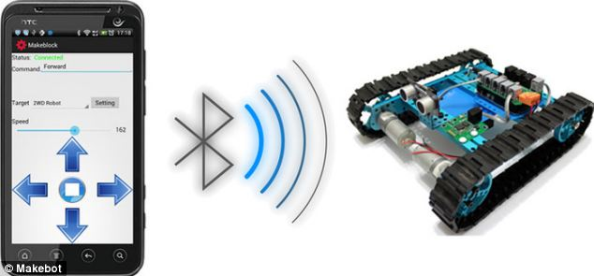
BLUETOOTH MODULE
16X2 LCD
LOAD 1
RELAY 2
RELAY 1
LOAD 2
R P S

ARDUINO UNO
(ATMEGA 328)

